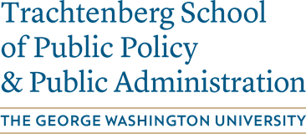

*The orientation will be in-person \*****Media and Public Affairs Building (MPA) 805 21ST ST NW, Washington, DC, 20006***

**Thursday, January 12: Welcome and Overview**

Please join us and meet the Trachtenberg Faculty, Staff, and Student Leaders.

**4:00 PM - 5:00 PM:** Career Services Drop-in Hour (optional, 15-20 minutes meetings for Career questions or resume reviews) by Denise Fowler and Melissa Feuer **RM 309**

**5:15 PM - 5:20 PM:** Trachtenberg School Director Welcome (Mary Tschirhart) **RM 310**

**5:20 PM - 5:30 PM:** Student Services Presentation by Gregory Nelson RM **310**

**5:30 PM - 5:35 PM:** Faculty Introduction **RM 310**

**5:35 PM - 6:00 PM:** Student org and Nashman Center Presentation **RM 310**

**6:00 PM - 6:30 PM:** Career Services Overview **RM 310**

**Program Breakout Sessions**: Please utilize the opportunity to meet with your Program Director and classmates as well as obtain vital program-specific information. (Graduate certificate students are welcome to join their program of interest)

**6:35 PM - 7:00 PM** ENRP Breakout Session by ENRP Program Co-Director, Rachel Emas RM **305**

**6:35 PM - 7:00 PM** MPA Breakout session by MPA Program Director, Anil Nathan RM **310**

**6:35 PM - 7:00 PM** MPP (snacks and refreshments) general lobby area.

**7:05 PM - 7:30 PM** MPP Breakout session by MPP Program Director, Anil Nathan RM **310**

**7:05 PM - 7:30 PM** ENRP and MPA (snacks and refreshments) general lobby area.

**7:45 PM - 8:30 PM** Student Org Sponsored Happy Hour at Tonic (2036 G St NW)